**Sample Questions**

**2 marks sample questions:**

1. Explain time and space complexity.
2. Explain Asymptotic notations.
3. Write methods to solve recurrence equations.
4. Write applications of any 2 data structures.
5. Explain trees with example.
6. Differentiate between divide & conquer and greedy algorithm.
7. Explain optimal solution.
8. Differentiate between dynamic programming and greedy algorithm.
9. How to represent graphs.
10. Write a note on N and NP classes.

**5 marks sample questions :**

1. Differentiate between singly and doubly linked list.
2. Differentiate between Breadth first search & Depth First search.
3. Find the complexity of the recurrence:

T(n) = { 2T(n-1) – 1, if n>0,

{ 1, otherwise

1. Consider the following set of integers.  
   {20,25,57,48,37,12,92,86,33}  
   If one uses the quick sort algorithm to sort the above set of integers, how many p to completely sort the file?  
   Note: you may choose middle element as a pivot?
2. How binary search trees are different from balanced binary search trees? Why balanced BSTs are better than BSTs?
3. Solve using fractional knapsack:

M=20, n=4

P= (3, 10, 15, 5)

W= (5, 13, 12, 8).

1. Find minimum spanning tree using prim and kruskal’s algorithm:



1. Write the Binary search algorithm and analyze for its best, worst and average case time complexity.
2. Differentiate between Breadth first search & Depth First search.
3. Find the shortest path from the given source S to all other vertices in the given graph using Dijkstra algorithm.

Start from source S=A.

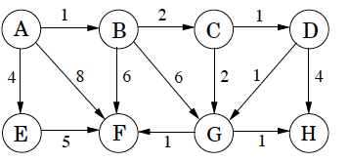

Note: if source is not given then take any vertex as source.

1. Write a brief note on Chinese Remainder theorem.
2. Write a brief note on Computational Complexity.
3. Write a brief note on String Matching Algorithms.
4. Determine the number of passes required to search the element 44 in the following list of elements 5,12,17,23,38,44,77,84,90 using selection sort.
5. Discuss about n-queen problem.
6. **marks sample questions:**
7. A networking company uses a compression technique to encode the message before transmitting over the network. Suppose the message contains the following characters with their frequency:



If the compression technique used is Huffman Coding, how many bits will be saved in the message?

1. Solve the following instance of 0/1 Knapsack problem using Dynamic programming n = 3; (W1, W2, W3) = (3, 5, 7);

(P1, P2, P3) = (3, 7, 12); M = 4.

1. **a)** How many bits may be required for encoding the message ‘mississippi’? Following is the frequency table of characters in ‘mississippi’ in non-decreasing order of frequency:

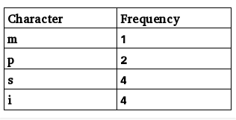

**b)** The characters a to h have the set of frequencies based on the first 8 Fibonacci numbers as follows: a : 1, b : 1, c : 2, d : 3, e : 5, f : 8, g : 13, h : 21

A Huffman code is used to represent the characters. What is the sequence of characters corresponding to the following code?

110111100111010

**c)** What are the steps to build a Huffman Tree from input characters? Explain with the help of an example.

1. What is the relation between P and NP class problems? Is P=NP? If No, then what will happen if P will become equal to NP?
2. Show step by step traversal of the following graph using DFS and BFS

Algorithm.

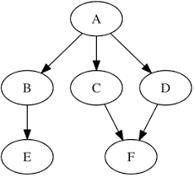

1. Given a string ‘S’, the problem of string matching deals with finding whether a pattern ‘p’ occurs in ‘S’ and if ‘p’ does occur then returning position in ‘S’ where ‘p’ occurs.  Solve this problem for the given string and pattern using Knuth-Morris-Pratt algorithm.

String : b a c b a b a b a b a c a a b

Pattern: a b a b a c a

1. Illustrate the working of string matching algorithms with example.
2. Write a brief note on NP-completeness and the classes-P, NP and NPC.
3. Traverse the following graph using Breadth First Traversal algorithm.

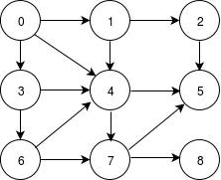

1. Explain spurious hits in Rabin-Karp string matching algorithm with example. Working modulo q=13, how many spurious hits does the Rabin-Karp matcher encounter in the text T = 2359023141526739921 when looking for the pattern P = 31415?
2. Construct all type of trees using below values :

1,2,3,4,5,6,7,8,9,10

1. Convert the given infix expression into postfix expression using stack.

(A + B) * C - (D - E) * (F + G)